



Time Limit: 1 hour

t



Se­nior High School ABM Pre-test

ALL

Topic 1 Introduction to Accounting Question View:

*Easy*

1.

2.

3.

4.

5.

6.

7.

8.

9.

10.

1. Represents the unexpired cost or remaining utility value of the asset.
2. Book Value
3. Market value
4. Zonal Value
5. Salvage Value

C = Correct

I = Incorrect

Finish

Previous

Next

icon excelcia 1

Create a Test Session

**Join**

Pre-test

Post-test

Exercises

Long-test

Major exam

Back

Back

icon excelcia 1

Create a Test Session

EXERCISES

Crossword Puzzles

Matching Type

Word Scrambles

Word Search

Back

icon excelcia 1

Topic 1- ACCOUNTING DEFINITION

00:00:00

Start Timer

­

Date: 07 – 23 – 2016

Learning Crossword Puzzles­­



Down

1. The financial statement that reports the financial position of a company as of an instant or point in time is the ________________ sheet.

7 letter word

_ _ _ _ _ _ _

Time Limit: 1 hour

Time Limit: 57 min. and 11 sec.

Exit

Submit

Discard

Save



Learning Word Scrambles

Date: 07 – 23 – 2016

00:00:00

Start Timer

icon excelcia 1

1. **Accounting is defined as _______________ of business.**
2. **American Association of Accountants describes accounting as the process of identifying, _______________, and communicating financial information.**
3. **_______________ is the first phase of accounting. – bookkeeping**
4. **The _______________, Philippine conquerors for hundreds of years, introduced bookkeeping system in the country. – Spaniards**
5. **Accounting provides information primarily _______________ in nature.**
6. **One of the areas of concern of accounting is keeping financial _______________.**
7. **Accounting always involves business _______________.**
8. **One of the major definitions of accounting is that it is a _______________ process.**
9. **_______________ is a service entity primarily aims to produce financial information useful in decision making.**
10. **Managers usually define accounting as a set of _______________.**
11. GLUAGNAE
12. EAMNGIRUS
13. KOEEIPNGOBK
14. DRSAINPAS
15. LCIANIANF
16. DRSORCE
17. TSONIRASNACT
18. INROFTOMIAN
19. CONUTNIGAC
20. UIDLIENESG

Next

Unscramble: 1. LANGUAGE

Discard

Save

Exit

Submit

Time Limit: 57 min. and 11 sec.

Time Limit: 57 min. and 11 sec.

icon excelcia 1

Save

Discard

00:00:00

Start Timer

Date: 07 – 23 – 2016

Exit

Submit

Discard

00:00:00

Start Timer

Learning Word Search

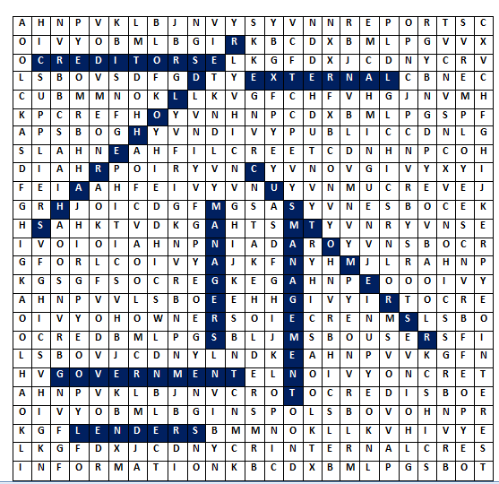

WORD SEARCH

1. Creditors
2. Managers
3. Lenders
4. Investors
5. Shareholders
6. Public
7. Government
8. Employees
9. Customers
10. Internal
11. External
12. Stakeholders
13. Interest
14. Directors
15. Owners
16. Suppliers
17. Management
18. Information
19. Users
20. Reports

Save

Time Limit: 57 min. and 11 sec.

Time Limit: 57 min. and 11 sec.

icon excelcia 1

00:00:00

Start Timer

Learning Matching Type

Date: 07 – 23 – 2016

A

.

B

C.

D.

E.

F

G

H

I

Forensic Accounting

Time Limit: 57 min. and 11 sec.

1. It involves the preparation of Financial Statements for all the stakeholders of the business.
2. Managers and other internal users utilize financial reports produced by _______________.
3. Proper usage of government funds is the primary concern of this branch of accounting.
4. It aims to give reliable independent opinion to the reports of the entity.
5. Tax compliance and tax management are some of the concerns of this branch of accounting.
6. _______________ manages the cost of production and the like.
7. It helps inform the students about the areas of accounting.
8. Accounting _______________ aids in improving the standards of accounting.

Tax Accounting

Accounting Education

Financial Accounting

Cost Accounting

Government Accounting

Internal

Auditing

Management Accounting

Discard

Exit

Submit

Save

Time Limit: 25 min and 7 sec

Time Limit: 57 min. and 11 sec.

Create a Test Session

icon excelcia 1C:\Users\acer i3-4thgen\AppData\Local\Microsoft\Windows\INetCache\Content.Word\Untitled-2.jpg

YOU CHOSE PRE-TEST

Now choose level of difficulty

EASY

Average

DIFFICULT

Back



ALL

Topic 1 Introduction to Accounting Question View:

Se­nior High School ABM M Long test

Time Limit: 1 hour

t



1. B I

2.

3.

4.

5.

6.

7.

8.

9.

10.

11

12

13

14

15

16

17

18

19

20

21

22

23

24

25

26

27

28

29

30

*Easy*

1. I. Periodicity concept is the assumption that the operating life of the business may be divided into time periods.

II. Monetary Concept states that the transactions recorded in the books of accounts and the elements reported in the income statements are expressed in terms of a common unit of measurement, the peso.

1. only I is true
2. only II is true
3. I & II Is true
4. I & II is false

You chose letter B

CANCEL

OK

Not Correct. Both statements are true. Periodicity may divide the operating business into time periods. Monetary concept, the elements reported in the income statement are expressed in terms of common measurement.

C = Correct

I = Incorrect

Finish

Previous

Next



C = Correct

I = Incorrect

ALL

Topic 1 Introduction to Accounting Question View:

Se­nior High School ABM Pre-test

Time Limit: 59 min. and 34 sec.

t

1. A

2.

3.

4.

5.

6.

7.

8.

9.

10.

*Easy*

1. Represents the unexpired cost or remaining utility value of the asset.
2. Book Value
3. Market value
4. Zonal Value
5. Salvage Value

You choose letter A

CANCEL

OK

Correct. It is cost less its accumulated depreciation. This value is based on the original cost of the asset less depreciation.

Finish

Previous

Next



Se­nior High School ABM Pre-test

Time Limit: 58 min. and 08 sec.

t

True or False

Topic 1 Introduction to Accounting Question View:

1. A C

2. C I

3. A C

4.

5.

6.

7.

8.

9.

10.

*Average*

1. Realization principle recognizes revenue when it is earned regardless of collection.
2. True
3. False

You chose letter A

CANCEL

OK

Correct.

Next

Finish

Previous

C = Correct

I = Incorrect



C = Correct

I = Incorrect

ALL

Topic 1 Introduction to Accounting Question View:

Se­nior High School ABM Pre-test

Time Limit: 57 min. and 11 sec.

t

1. A C

2. C I

3.

4.

5.

6.

7.

8.

9.

10.

CANCEL

OK

*Easy*

Not correct. It is the asset owned and contributed in a business.

1. The owner may also make withdrawals in the form of property which should be recorded at its original cost.
2. Owner’s Capital
3. Owner’s Equity
4. Owner’s Asset
5. Owner’s Drawing

You Choose letter C

Finish

Previous

Next